CHAPTER 1

Introduction

Alphaviruses

The alphaviruses are a group of 29 serologically related virus species that belong to the family Togaviridae (Strauss and Strauss 1994; van Regenmortel 2000). There are at least seven complexes, or groups, of antigenically related members of the alphavirus genus (Griffin 2007). The alphaviruses, as a group, occur throughout most of the world, are transmitted by hematophagous insects (primarily mosquitoes) and many have been associated with human morbidity and mortality (van Regenmortel 2000; Griffin 2007). Most alphaviruses are able to infect diverse vertebrate species including birds, mammals, amphibians and reptiles (van Regenmortel 2000). Many Old World alphaviruses cause non-life threatening illness in humans; however the New World alphaviruses are known to regularly cause fatal encephalitis (van Regenmortel 2000).
Alphaviruses have positive, or messenger-sense genomes comprised of 11-12 kb of single-stranded RNA. The nonstructural replication proteins (nsp1—nsp4) are encoded in the 5’ portion of the genome while the structural proteins are encoded in the genes of the 3’ end. The three main structural proteins are capsid (C), envelope glycoprotein 1 (E1) and envelope glycoprotein 2 (E2). The virion binds to the surface and enters the cell via receptor-mediated endocytosis. The precise receptor used is uncertain as several have been identified in cell culture systems and the E2 protein may contain multiple receptor recognition residues (Griffin 2007). Following fusion of the viral envelope with the host cell membrane the messenger sense genome is released into the cytoplasm and non-structural genes are translated for the formation of the replication complex. This replication complex, comprised of 4 multifunction proteins then creates minus-sense copies of the genome that serve as templates for creation of new genomes for packaging into budding virions. The structural proteins are translated from a subgenomic message and the envelope proteins are processed by the endoplasmic reticulum and golgi complex before combining with nucleocapsids (genomic RNA and capsid proteins) at the cell surface for budding to produce nascent virions (Kuhn 2007).

Serotypes and Classification of VEEV

Venezuelan equine encephalitis (VEE) is caused by Venezuelan equine encephalitis virus (VEEV), an alphavirus that is transmitted by mosquito bite and can cause severe disease in humans and equids (Beck and Wyckoff 1938; Gilyard 1944; Gilyard 1945; Johnson and Martin 1974). Prior to the advent of genetic sequence analysis, relationships and antigenic classification of many arboviruses was based on hemagglutination inhibition tests (Casals 1964; Hammam, Clark et al. 1965). These tests were used to classify arboviruses into groups A, B and C that now correspond to alphaviruses, flaviviruses and members of the bunyavirus family, respectively (Griffin 2007). Similar serological cross-reaction studies revealed that VEEV actually comprises multiple subtypes and that subtype I comprises 5 distinct variants: IAB, IC, ID, IE and IF (Figure 1.1). Variety IAB was formerly considered two variants, IA and IB (Johnson and Martin 1974) but was later grouped into one. However, recent genetic analysis provides support for the original classification with IA and IB considered separate variants (Weaver, Pfeffer et al. 1999). Historically only variants IAB and IC have been known to cause equine disease – the others, ID, IE and IF continuously circulate in sylvatic foci but have not been known to cause outbreaks of disease in horses (Table 1.1).
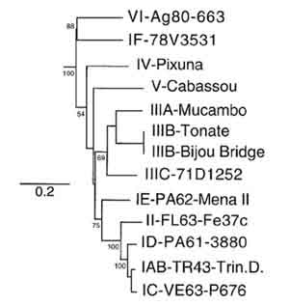
Figure 1.1: Phylogenetic tree of prototype VEE complex viruses. Phylogeny is based on nucleotide sequences of an 817 base pair fragment of the E2-E3 region and created using the PAUP parsimony algorithm. Numbers indicate bootstrap values for groups to the right. (reprinted with permission from Powers et al. 1997).

The term epizootic is used to describe strains of VEEV that are known to cause severe disease and replicate to high-titer viremia in horses. In epizootic outbreaks horses are the main amplifying host and equinophilic mosquitoes are the vectors that transmit the virus (Figure 1.2). Strains that are not known to cause disease in horses are called enzootic. These strains are able to cause disease in humans and are thought to utilize ground dwelling rodents as primary amplifying hosts. In the case of subtype IE VEEV the terms enzootic and epizootic are not clearly applicable. Because of the lack of known equine outbreaks, subtype IE VEEV was always considered enzootic and unable to
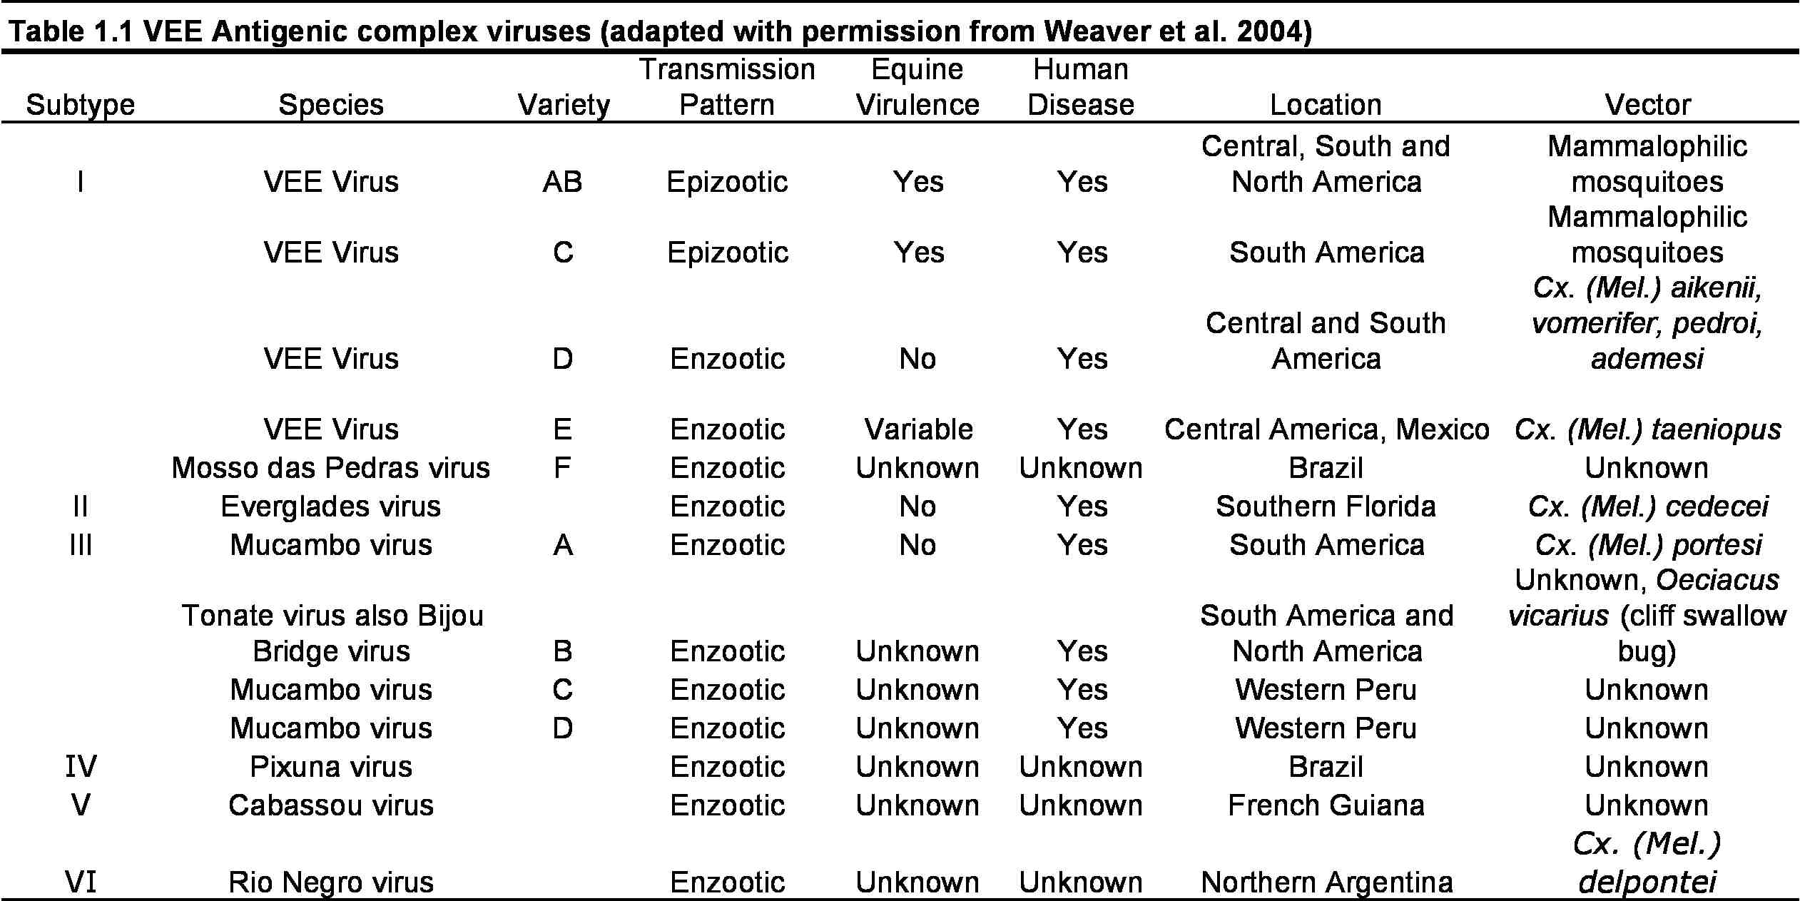
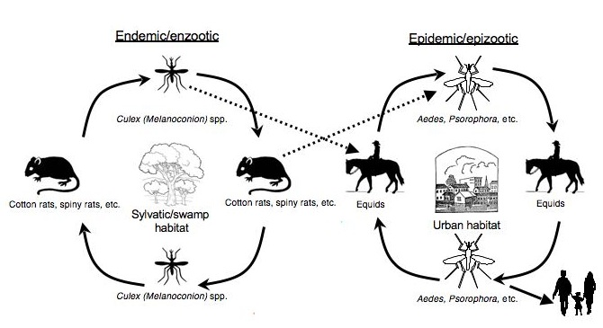
replicate to high titer in horses. However, recent outbreaks cast subtype IE VEEV in a new light and subsequent experimental infections of horses have reported titers comparable to epizootic strains (Dr. A.P. Adams and Dr. R. Bowen unpublished data). For clarity of discussion, subtype IE VEEV strains isolated during or after the recent outbreaks will be called “equine-virulent” and those isolated before the outbreak will be called enzootic. Strains belonging to other VEEV subtypes, IAB, IC and ID will be referred to in the traditional epizootic/enzootic nomenclature.

Figure 1.2: Enzootic and epizootic transmission cycles of Venezuelan equine encephalitis virus. Enzootic cycles are transmitted by Culex (Melanoconion) mosquitoes and not associated with large outbreaks of equine or human disease. Epizootic cycles are transmitted by equinophillic mosquito species and cause large epizootic outbreaks of disease in equines and humans.

Venezuelan equine encephalitis virus, although not confined to Venezuela, is so named because it was first recognized in the 1930’s in Venezuela as an agent of disease in equids—horses, mules and donkeys (Young and Johnson 1969). Subtypes IAB and IC have only been isolated during epizootics and have been found repeatedly in Venezuela, Colombia, Ecuador and Peru. Additionally, during an especially large and widespread epizootic, subtype IAB VEEV was found in Nicaragua, Honduras, El Salvador, Guatemala, Mexico and the United States (Texas). Subtype ID was originally isolated in Panama and has been found in Venezuela, Colombia, Ecuador and Peru (Walder and Suarez 1976; Dickerman, Cupp et al. 1986)(Scherer and Anderson 1975; Oberste, Weaver et al. 1998). This subtype has been repeatedly isolated from wild mosquitoes and rodents as well as febrile humans, but never from horses. Subtype IE was considered enzootic and had not been associated with equine disease until 1993. Prior to 1993 this subtype was known to occur in enzootic transmission cycles from Panama to Mexico (Scherer, Dickerman et al. 1964; Scherer, Dickerman et al. 1970; Oberste, Fraire et al. 1998). Subtypes ID and IE are believed to be the enzootic precursors from which subtypes IAB, IC and equine-virulent subtype IE emerged (Powers, Oberste et al. 1997; Brault, Powers et al. 2002). Subtype IF, known as the species Mosso das pedras virus is also considered enzootic and has only been found in Brazil, where it was originally isolated from a Culex (Melanoconion) mosquito pool (Calisher, Kinney et al. 1982).

Disease in Equids and Humans

Infection of equids with epizootic VEEV is associated with a high frequency of encephalitis resulting in 19-83% mortality (Weaver, Ferro et al. 2004). Donkeys experience particularly frequent mortality that has been reported to be as high as 91% (Gilyard 1945). Occasionally infection can be inapparent though most often animals present with fever, tachycardia, depression, circling and anorexia (Walton, Alvarez et al. 1973). Dramatic signs of disease are not uncommon and include uncontrollable violence or continual galloping to the point of collapse (Gilyard 1945). Encephalitis develops within 5-10 days after infection and is quickly followed by death. Venezuelan equine encephalitis outbreaks in equids can be extremely detrimental to the rural communities where they most often occur because the affected animals are relied upon for both transportation and agricultural activities. A vaccine is available for use in horses; however it is not licensed for use in humans because of a high rate of morbidity (Alevizatos, McKinney et al. 1967). The vaccine strain is a live-attenuated strain designated TC-83 and was acquired through serial passaging of virulent subtype IA VEEV. Prior to the development of this live-attenuated vaccine inactivated vaccines were used; however incomplete inactivation of these vaccine preparations has been implicated as the cause of many outbreaks in South America during the 1960’s and 1970’s (Weaver, Pfeffer et al. 1999).
In humans VEE disease is less severe, usually described as a self-limiting non-specific febrile illness though it is sometimes entirely asymptomatic. Most of the pathology associated with VEEV infection can be attributed to destruction of B-cells, vascular endothelial cells, hepatocytes and cerebral cortex neurons (de la Monte, Castro et al. 1985). The lymphocytopenia and resulting immunosuppression seen in human disease is thought to be the result of lymphophagocytosis due to the expression of VEEV antigen on the surface of infected cells (de la Monte, Castro et al. 1985). Interstitial pneumonia is very common in human infection (90%) although is not seen in experimental animal infection (de la Monte, Castro et al. 1985). Equine pathogenesis studies with Mexican subtype IE VEEV strains, conducted in collaboration with the Centro Nacional de Investigaciones en Microbiologia, at the Instituto Nacional de Investigaciones Frestales, Agricolas y Pecuarias, in Mexico City and with Colorado State University, showed greatly reduced levels of viremia as compared to experimental equine infection with subtype IAB or IC VEEV (Kramer and Scherer 1976; Wang, Bowen et al. 2001; Gonzalez-Salazar, Estrada-Franco et al. 2003). However, a more recent study found that a strain of subtype IE VEEV isolated in 2001 was able to induce viremia in horses comparable to an epizootic IC strain (Dr. A. Paige Adams, personal communication).

Emergence and Re-emergence

The first recognized epizootic of VEE disease in equids occurred in the 1930’s in Venezuela (Young and Johnson 1969). Subsequent outbreaks were recorded on the island of Trinidad in 1943 and in Colombia in 1952 (Sanmartin-Barberi, Groot et al. 1954). From 1962 to 1964 a very large outbreak occurred in Venezuela with 32,000 documented human cases and nearly 200 deaths (Sellers, Bergold et al. 1965). Outbreaks occurred in northern South America from Peru to Venezuela up until 1973, when the virus was believed to have disappeared. However, in 1992 and 1995 new outbreaks attributed to the IC variety occurred in Venezuela and western Colombia and involved up to 100,000 humans (Rico-Hesse, Weaver et al. 1995; Weaver, Salas et al. 1996).
In 1971 the United States experienced its first (and so far, only documented) outbreak of VEE. This was one of the most widespread VEE outbreaks recorded and was caused by subtype IAB VEEV. It is thought to have originated in Ecuador possibly as the result of an incompletely inactivated vaccine and to have been transported to Nicaragua and spread northward through Central America and Mexico to finally reached Texas in 1971 (Figure 1.3). There were 93 human deaths and over 50,000 equine deaths in Mexico alone. Though there were no human fatalities in the United States, there were over 300 cases of human illness and over 1500 equine deaths (Sudia, Fernandez et al. 1975).
In the mid-90’s two epizootic outbreaks occurred in the Chiapas and Oaxaca States of southern Mexico, with the causative agent determined to be subtype IE VEEV which had previously been considered equine avirulent (Oberste, Fraire et al. 1998). In these two outbreaks there were 163 total equine cases due to subtype IE VEEV infection and 75 (46%) were fatal (Oberste, Fraire et al. 1998). No human cases were reported; however, it is likely that a large number of people were exposed and didn’t develop disease severe enough to report or their illness was misdiagnosed as dengue fever. Recent human serosurvey data show seroprevalence of up to 75% in some areas of Chiapas State (Estrada-Franco, Navarro-Lopez et al. 2004). Because dengue virus is endemic in this area non-encephalitic febrile illnesses are often misdiagnosed or unreported. Although there were no human deaths reported due to infection with subtype IE VEEV during these outbreaks it is nevertheless important to understand the changes enabling the shift from equine avirulent to virulent. Based on the spread of the 1971 epidemic, an outbreak of highly virulent VEEV in southern Mexico could quickly reach the United States.
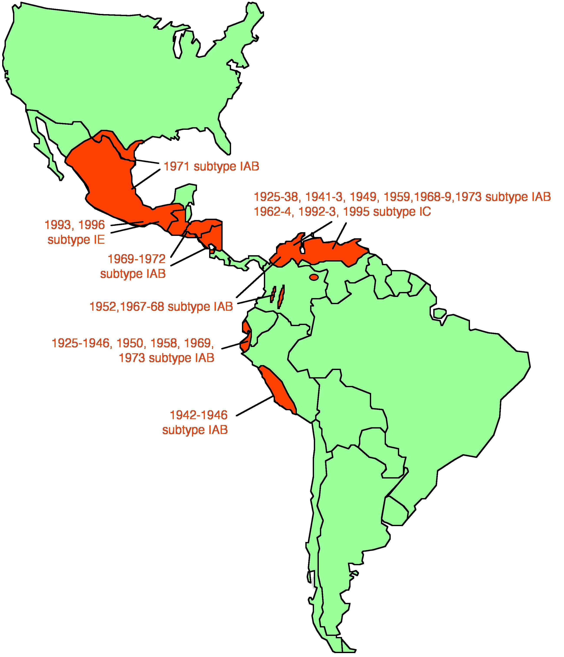

Figure 1.3: Known VEEV epizootics. Map of the America’s showing location, year and subtype involved in all the known major epizootics of Venezuelan equine encephalitis virus. (reprinted with permission Weaver et al, 2004).

The 1993 Chiapas and 1996 Oaxaca outbreaks of subtype IE VEEV in southern Mexico present an interesting example of VEEV emergence. In general, mutations in one particular enzootic subtype ID VEEV lineage are thought to account for the emergence of epizootic IAB and IC strains and it is now believed that subtypes IAB and IC have emerged multiple times from ID precursors (Powers, Oberste et al. 1997). These emergence events were mediated by mutations in the E2 envelope glycoprotein, which is thought to participate in virion binding to target cells (Brault, Powers et al. 2002). Similar mutations have been found in the E2 gene sequences of equine-virulent subtype IE VEEV strains isolated during the Mexican outbreaks (Brault, Powers et al. 2002). Genetic sequence comparisons suggest that virulent subtype IE VEEV strains emerged from avirulent subtype IE VEEV strains previously found to circulate in the area (Oberste, Fraire et al. 1998). However, comparisons of multiple enzootic and epizootic sequences failed to reveal convergent amino acid substitutions, suggesting multiple mutations or combinations of mutations could be responsible for the equine-virulent phenotype (Brault, Powers et al. 2002).

History of VEEV in Mexico

Subtype IE VEEV has been known to circulate in southern Mexico since the early 1960’s (Figure 1.4) (de Mucha Macias 1963; Scherer, Dickerman et al. 1964; de Mucha Macias, Sanchez-Spindola et al. 1966). It was first identified in humans in the state of Campeche during a small outbreak of disease that included 5 fatalities (de Mucha Macias, Sanchez-Spindola et al. 1966). The first isolates were collected from mosquito pools and a sentinel hamster in the state of Veracruz in 1963 (Scherer, Dickerman et al. 1964). In 1966, in northern Veracruz and the neighboring state of Tamaulipas, a small outbreak consistent with VEE was reported in horses though it was not confirmed serologically or by virus isolation (Morilla-Gonzalez and de Mucha-Macias 1969). From 1961 to 1967 an extensive field study was carried out in southeastern Mexico during which time virus was isolated repeatedly from mosquitoes, wild and domestic animals and from humans (Scherer, Dickerman et al. 1971; Scherer, Dickerman et al. 1971; Scherer, Dickerman et al. 1971) (Scherer, Campillo-Sainz et al. 1972). More recently, two serosurveys of wild and domestic animals suggested circulation of subtype IE VEEV in the northern states of Coahuila and Nuevo Leon as well as in the eastern-most portion of Chiapas State far from the site of the 1993 outbreak (Aguirre, McLean et al. 1992; Ulloa, Langevin et al. 2003).
In 1969 an outbreak of introduced subtype IAB VEEV that had been spreading through Central America crossed into Mexico and quickly crossed the Isthmus of Tehuantepec that separates the states of Oaxaca and Veracruz from the states of Tabasco and Chiapas. Once the virus reached the gulf coast of Mexico it spread steadily northward and reached Texas in 1971(Franck and Johnson 1971). Extensive subsequent field-studies were unable to find evidence that the virus had established new enzootic foci of subtype IAB VEEV (Sudia, Fernandez et al. 1975; Sudia, Newhouse et al. 1975; Scherer, Anderson et al. 1976; Scherer, Ordonez et al. 1976). Since the 1993 outbreak in Chiapas, approximately 25 serologically confirmed equine cases of VEEV infection have occurred including eight equine deaths. Recently, new subtype IE VEEV isolates have been made in Veracruz state from sentinel hamsters and there were 6 serologically confirmed equine cases in 2008 in and around the same region as the 1993 outbreak. Additionally, there have been over 100 serologically confirmed cases of human infection over the past several years (Dr. Jose Estrada-Franco, personal communication).

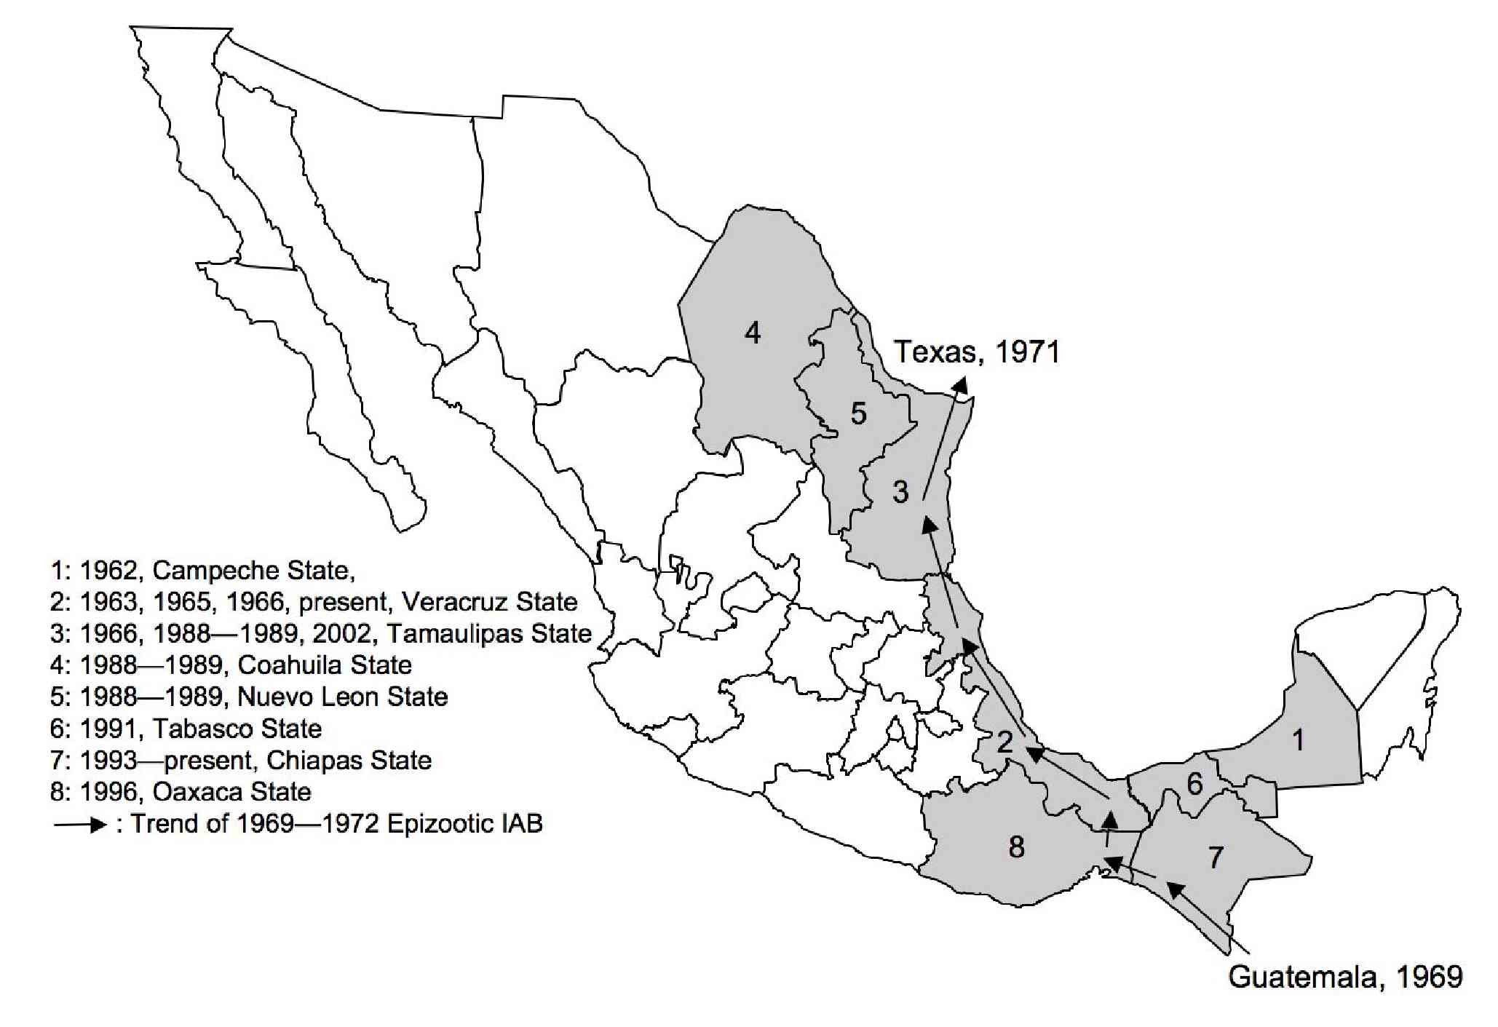

Figure 1.4: The history of subtype IE VEEV in Mexico. Shaded states indicate areas with documented VEEV activity—horse disease/death, wildlife seropositivity, virus isolation and/or human seropositivity. Numbers indicate state only and do not indicate the region within the state where VEEV activity occurred. Arrows indicate the path of the 1969 epizootic of subtype IAB and is included for reference purposes

Mosquito Vectors

Vector competence is an important factor in emergence of an epizootic VEEV strain from enzootic progenitor strains. In order for a particular mosquito to be an efficient vector three critical events are necessary: 1) the mosquito must ingest a sufficient amount of virus to infect the epithelial cells of the midgut; 2) sufficient replication of the virus must occur in the mosquito midgut for the virus to disseminate into the hemoceol and subsequently to the salivary glands; 3) salivary gland tissue must become infected and virus must be shed in the saliva (Yuill 1986). Variation in the ability of VEEV to achieve these three events exists between different mosquito species and between different strains of virus.
Proven vectors of epizootic VEEV are Aedes (Ochlerotatus) taeniorhynchus and Psorophora confinnis while Mansonia titilans, Ma. indubitans, Aedes (Ochlerotatus) sollicitans, and Culex nigripalpus are suspected vectors of epizootic VEEV(Gilyard 1944; Sudia and Newhouse 1975). Aedes taeniorhynchus is one of the mosquito species most often associated with epizootic VEEV transmission (Sudia, Newhouse et al. 1975; Kramer and Scherer 1976). Aedes taeniorhynchus has been experimentally shown to be more susceptible to epizootic VEEV strains than to enzootic VEEV strains (Turell, O'Guinn et al. 2003; Ortiz and Weaver 2004). Interestingly, Ae. taeniorhynchus has been shown to also be more susceptible to the equine-virulent subtype IE VEEV than to closely related enzootic subtype IE VEEV strains (Brault, Powers et al. 2002). During the 1971 epizootic in Texas, four mosquito species were found to be probable primary vectors of epizootic VEEV: Aedes sollicitans, Ps. discolor (Coquillett, 1903), Ps. confinnis, Ae. thelcter (Sudia, Newhouse et al. 1975). These species were among the most abundant at that time and are known to favor large domestic animals for blood feeding. Psorophora discolor and Ps. confinnis are known to use larval habitats that are closely associated with livestock and have been shown to take up to 9 bloodmeals (Sudia, Newhouse et al. 1975). Psorophora confinnis has been shown experimentally to be an efficient transmitter of VEEV and is considered an important bridge vector (Ortiz, Anishchenko et al. 2005).
Enzootic VEEV is maintained in natural transmission cycles by mosquitoes of the Culex subgenus Melanoconion. More specifically, by members of the Spissipes section of this subgenus, which comprises 18 species (Ferro, Boshell et al. 2003; Navarro and Weaver 2004; Weaver, Ferro et al. 2004). These are closely related, phenotypically similar species with distinct geographical distributions. The systematics of the Spissipes section has been continually revised owing to subtle variation between and within species and difficulty in laboratory rearing (Galindo 1969; Sirivanakarn and Belkin 1980). In Guatemala, the proven vector of subtype IE VEEV is Culex (Melanoconion) taeniopus [formerly Cx. opisthopus (Sirivanakarn and Belkin 1980)]. In Panama a proven vector of subtype ID VEEV is Cx. (Mel.) aikenii sensu lato (Galindo and Grayson 1971). In one region of Venezuela three different species have been proven as important vectors of VEEV ID: Cx. (Mel.) vomerifer, Cx. (Mel.) pedroi and Cx. (Mel.) adamesi (Ferro, Boshell et al. 2003). In Florida, Everglades virus (VEEV complex subtype II) is transmitted by Cx. (Mel.) cedecei (Chamberlain, Sudia et al. 1964) (Weaver and Scherer 1986) and in Trinidad, Mucambo virus (VEEV subtype IIIA) is transmitted by Cx. (Mel.) portesi (Aitken 1972). A non-Melanoconion species, Cx. (Deinocerites) psuedes (formerly Deinocerites psuedes) has been experimentally shown to transmit enzootic subtype ID VEEV; however this study was done with higher titer bloodmeals that are typically available from reservoir rodent hosts and therefore its implications for natural transmission cycles are limited (Grayson and Galindo 1972).
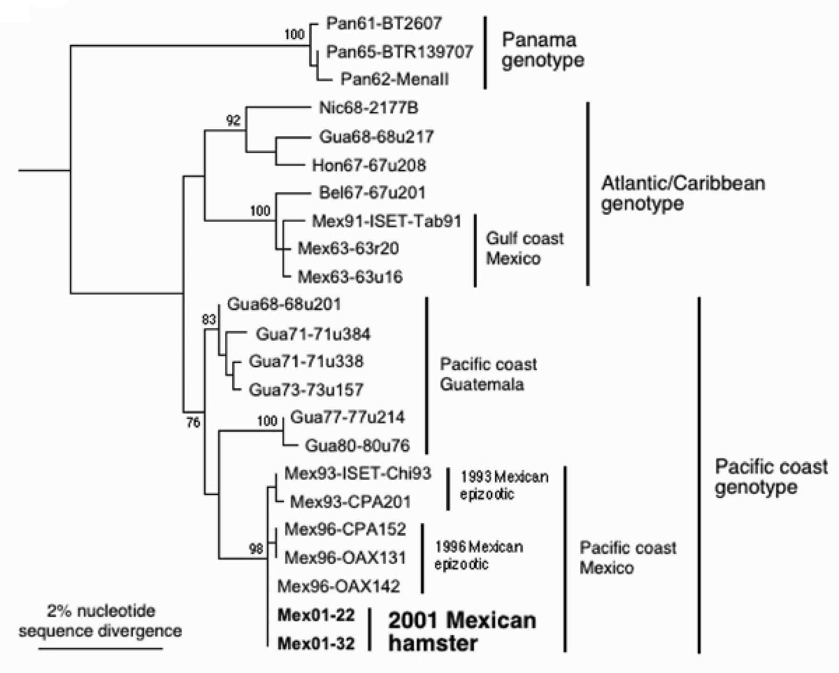
Figure 1.5: Relatedness of subtype IE VEEV strains. Maximum parsimony phylogenetic tree derived from partial PE2 envelope glycoprotein precursor gene sequences showing relationships of the newly isolated Venezuelan equine encephalitis virus (VEEV) strains from sentinel hamsters (Mex01-22 and Mex01-32) to other subtype IE strains . Strains are designated by country abbreviation followed by year of isolation and strain designation. Numbers indicate nucleotide substitutions assigned to each branch. (Estrada-Franco et al, 2004).

Culex (Mel.) taeniopus has an oral infection threshold for epizootic viruses of around 10⁴ plaque forming units (pfu) per bloodmeal (Scherer, Weaver et al. 1986). Even at titers as high as 10^{5.4} pfu, infection rates remain low and transmission does not occur (Scherer, Weaver et al. 1986). This incompetence is thought to be due to a midgut barrier to infection (Scherer, Cupp et al. 1982; Weaver, Scherer et al. 1984). Conversely, this species has been shown to become infected and to transmit enzootic virus after ingesting bloodmeals with titers as low as 10^{0.7}pfu (5 infectious units) (Scherer, Weaver et al. 1986).
It has been proposed that Mexican equine-virulent subtype IE VEEV adapted to the more abundant species, Ae. taeniorhynchus, as an alternate vector after habitat destruction caused a substantial reduction in Cx. taeniopus populations (Brault, Powers et al. 2004). Adaptation to a more abundant vector may provide some compensation for the reduced levels of equine viremia observed in epizootic subtype IE VEEV infections (Brault, Powers et al. 2002). A single amino acid substitution within the viruses E2 glycoprotein gene has been shown to be sufficient for this adaptation by VEEV to a more efficient epizootic vector (Brault, Powers et al. 2002). Virus strains isolated during and since the Mexican outbreaks contain mutations in the E2 glycoprotein gene and group together phylogenetically (Figure 1.5) (Estrada-Franco, Navarro-Lopez et al. 2004).
Traditionally the criteria for definitive vector incrimination are: 1) demonstration of feeding on (or other effective contact with) a vertebrate amplification host species; 2) time and space association between vector and pathogen; 3) experimental transmission of pathogen by vector; 4) repeated demonstration of natural infection (Barnett 1960). Aedes taeniorhynchus is known to feed primarily on horses and cows, but occasionally on smaller mammals or humans (Cupp, Scherer et al. 1986). Field capture data together with serosurvey data confirm a time and space association of Ae. taeniorhynchus and subtype IE VEEV in Chiapas. Wild caught Ae. taeniorhynchus have been shown to be susceptible to subtype IE VEEV infection and capable of transmitting it as well (Kramer and Scherer 1976; Turell, O'Guinn et al. 2003). What remains to be demonstrated for the incrimination of Ae. taeniorhynchus as the primary subtype IE VEEV vector is repeated demonstration of natural infection. Alternatively, Cx. taeniopus mosquitoes are known to be efficient vectors of enzootic subtype IE VEEV; however this species of mosquito was not considered abundant enough in coastal Chiapas to be the primary vector in this area. It has been shown that the recent strains of equine-virulent subtype IE VEEV are better able to infect the epizootic vector Aedes taeniorhynchus than equine avirulent strains. Reciprocal loss of fitness in an enzootic vector species such as Cx. taeniopus has not been addressed experimentally.

Ground-dwelling Mammalian Reservoirs and Amplifying Hosts

Horses and humans are not the main species infected by VEEV and related viruses. In natural, continuous enzootic transmission cycles these viruses infect small mammals, usually rodents (Figure 1.2). It is thought that these viruses are in constant circulation among their principal reservoirs and that horses and humans are incidental spillover hosts not required for maintenance of the natural cycle. Criteria for reservoir identification may be considered similar to those for vector incrimination. They include: 1) demonstration of feeding on by a vector; 2) time and space association between reservoir species and pathogen; 3) experimental infection by pathogen; 4) repeated demonstration of natural infection. Species of several rodents and ground-dwelling mammal have partially satisfied these criteria.
The hispid cotton rat (Sigmodon hispidus) is considered an important amplifying host in enzootic VEEV cycles. It is a medium to large-sized coarse-haired rat that grows up to 365mm in length and can weigh up to 200g (Chipman 1965). Sigmodon hispidus are found throughout Central America as well as in Mexico and the southern half of the United States. They breed throughout the year in the tropics and typically have several litters of 1-15 pups a year, with smaller litters in tropical regions (Cameron and Spencer 1981; Reid 1997). Populations of S. hispidus have been reported to fluctuate cyclically reaching high densities of 20—24 per hectare every 2—5 years (Schwartz and Schwartz 1981). One study found a population spike from 0 to 112 and back to 0 animals/ha over a one-year period (Clark, Hellgren et al. 2003). These animals favor dense grassy fields, brushy weedy areas or reeds and cattails along streambeds. They build nests either underground or under logs or rocks. The home range for a single animal is between 0.22—0.35 ha and they are most active between 7pm and 9am (Layne 1974; Cameron, Kincaid et al. 1979). Previous studies report a high incidence of VEEV-specific antibodies and virus isolation from this species (Galindo, Srihongse et al. 1966; Scherer, Dickerman et al. 1976; Estrada-Franco, Navarro-Lopez et al. 2004). In addition, several studies have shown certain populations of S. hispidus animals to be susceptible to and able to survive high-titered infection with VEEV strains (Coffey, Carrara et al. 2004; Carrara, Coffey et al. 2007) (Scherer, Dickerman et al. 1971). Experimental infections with more recent subtype IE VEEV strains isolated since the Mexican 1993 outbreak have not previously been performed (Cameron, Kincaid et al. 1979). It has recently been reported that the current designation S. hispidus likely comprises 3 cryptic species: S. hispidus, S. hirsutus and S. toltecus (Carroll and Bradley 2005).
Another species implicated in natural VEEV transmission cycles by previous seroprevalence studies is Coues’ rice rat (Oryzomys couesi) (Scherer, Dickerman et al. 1971; Scherer, Dickerman et al. 1976; Scherer, Dickerman et al. 1985). This species was considered for a time to be conspecific to Oryzomys palustris, thus previous reports of VEEV antibody and virus for both species must be considered (Benson and Gehlbach 1979; Wolfe 1982). Oryzomys couesi animals are medium sized rats that are commonly found throughout Central America and in the southern portion of Texas (Reid 1997). They also breed throughout the year and the average litter size is 5 pups. The home range of an adult is approximately 0.4 ha with densities averaging between 2—12 animals/ha (Benson and Gehlbach 1979). A strong swimmer, this animal prefers herbaceous wetland habitat such as cattail-bulrush marsh. Nests have been found in cattails or trees up to 2 meters above the water surface and are usually within 5 meters of the shore (Benson and Gehlbach 1979; Reid 1997). In addition to VEEV, O. couesi has been implicated in the natural transmission cycle of the hantavirus species Catacamas virus (Milazzo, Cajimat et al. 2006).
Salvin’s spiny pocket mouse (Liomys salvini), is an abundant species found from southern Mexico (Chiapas) along the pacific coast of Central America as far south as central Costa Rica (Reid 1997). These medium-sized pocket mice live underground in elaborate burrow systems where they hoard seeds in food caches (Fleming and Brown 1975). Liomys salvini burrows are found in deciduous forest, weedy fields or along rocks and walls (Reid 1997). Breeding is thought to occur primarily from January to June, average litter size is 4 and females produce 1—2 litters a year (Goodwin 1946). These animals fight viciously when placed in captivity together and wild population densities can range from 4—9 animals/ha. Liomys salvini and its northern relative Liomys irroratus have been occasionally found to have VEEV-specific antibodies (Sudia, McLean et al. 1975; Scherer, Dickerman et al. 1976; Scherer, Dickerman et al. 1985).
The fulvus pygmy rice rat (Oligoryzomys fulvescens) is a small rodent that is found from central Mexico through most of Central America and in much of northern South America. They are found in lowland dry forest, brush and tall grasses and along forest edges. Breeding occurs throughout the year, but primarily during the rainy season and the average litter size is 4 young (Hall and Dalquest 1963). This species was formerly included in the genus Oryzomys and is now thought to comprise several closely related species (Musser and Carlton 1993). Oligoryzomys fulvescens is thought to be important in the transmission cycle of Choclo virus, a hantavirus that causes human disease in Panama (Vincent, Quiroz et al. 2000; Peters and Khan 2002).
The southern pygmy mouse (Baiomys musculus) is a small diurnal mouse. Though not previously implicated in VEEV transmission cycles, B. musculus has been previously reported to occur sympatrically with Sigmodon hispidus, Liomys salvini, Oligoryzomys fulvescens and Oryzomys palustris/couesi (Carter and Genoways 1978; Packard and Montgomery 1978). This species is thought to comprise two geographically distinct clades in Mexico; a northwestern clade and a southern clade (Amman and Bradley 2004). The southern clade of B. musculus has a distribution from the Mexican state of Michoacan to northern Nicaragua (Amman and Bradley 2004). They are commonly found in weedy or uncleared fields or along rock walls and piles (Packard and Montgomery 1978). Nests are built either under rocks or in underground burrows and may be communal (Packard 1960). Mating probably occurs year-round and average litter size is 3 young.
Common opossums (Didelphis marsupialis) have been found to have VEEV-specific antibodies and also have occasionally yielded VEEV isolates (Scherer, Dickerman et al. 1971; Sudia, McLean et al. 1975; Scherer, Dickerman et al. 1976; Scherer, Dickerman et al. 1985; Estrada-Franco, Navarro-Lopez et al. 2004). This opossum is found from central Mexico, through Central America and throughout the northern half of South America (Reid 1997). Females produce two or more litters per year with up to 20 young in a litter; however nipple and pouch accommodation leads to high mortality and reduces the number to an average of 6 pouch young. Home ranges can be as large as 123 ha for males and 16 ha for females and densities of 0.1—1.3 animals/ha have been reported (Fleming 1972).
Spiny rats (Proechimys semispinosus) are large rats that, though not found in Mexico, have been implicated in natural transmission of enzootic VEEV in Central and South America (Grayson and Galindo 1968; Young and Johnson 1969; Carrara, Gonzales et al. 2005). Their range extends from eastern Honduras through southern Central America and into the pacific coastal regions of Colombia and Ecuador (Reid 1997). The preferred habitat is lowland evergreen or deciduous forest. Proechimys semispinosus animals are solitary, nest under logs or in dense vegetation and will occasionally burrow in the day. Females breed up to four times a year and litters range in size from 1—5 young (Reid 1997).
Another rodent not found in Chiapas, but thought to participate in natural cycles of VEEV transmission is the short-tailed cane mouse (Zygodontomys brevicauda). This species is considered synonymous with Z. microtinus, the latter name being given to populations north of the Orinoco River in Venezuela (Aguilera 1985). These are medium sized mice found in Costa Rica and Panama and across most of northern South America (Reid 1997). Zygodontomys brevicauda animals are primarily found in a variety of habitats including grassland, marshes, clearings and areas of secondary growth (Reid 1997). Nests are built in cracks or burrows in the ground or under trees and breeding occurs year-round with average littler size of 4 (Reid 1997). In laboratory experiments Z. microtinus was shown to be a potential vertebrate reservoir host of VEEV subtype ID (Young, Johnson et al. 1969). Zygodontomys brevicauda has also been associated with Guanarito virus, an arenavirus that causes human disease in Venezuela (Fulhorst, Bowen et al. 1999).
Other ground-dwelling mammal species found to occasionally have enzootic VEEV-specific antibodies include: Central American porcupine (Coendou mexicanus), variegated squirrel (Sciurus variegatoides), red squirrel (Sciurus granatensis), forest spiny pocket mouse (Heteromys anomalus), four-eyed opossum (Philander opossum), Mexican deer mouse (Peromyscus mexicanus), cotton mouse (Peromyscus gossypinus), roof rat (Rattus rattus), rice rats (Oryzomys laticeps, O. concolor, O. calignosus), neotropical water rat (Nectomys squamipes), forest rabbit (Sylvilagus brasiliensis), long-tailed weasel (Mustela frenata), raccoon (Procyon lotor) and paca (Agouti paca) (Scherer, Dickerman et al. 1971; Scherer, Dickerman et al. 1976; Scherer, Dickerman et al. 1985). Of these, the only one from which enzootic VEEV has been isolated is the four-eyed opossum (Philander opossum) (Scherer, Dickerman et al. 1971).

Birds and Bats as VEEV Amplifying Hosts

The role of birds and bats is likely in enzootic VEEV dispersal rather than virus amplification (Weaver, Ferro et al. 2004). In Guatemalan field studies many species of birds demonstrated VEEV-specific antibodies: green heron (Butoirides virescens), mottled owl (Ciccaba virgata), green kingfisher (Chloroceryle Americana), golden-fronted woodpecker (Centurus aurifrons), rose-throated becard (Platypsaris aglaiae), ivory-billed woodpecker (Xiphorhynchus flavigaster), derby flycatcher (Pitanus suphuratus), rufus-naped wren (Campylorhynchus, rufinucha), clay-colored robin, (Turdus grayi), boat-tailed grackle (Cassidix mexicaus), strip-headed sparrow (Aimophila ruficauda). The seroprevalence in birds ranged form 1—10% and antibody titers were low (Scherer, Dickerman et al. 1976). Thus, VEEV is occasionally able to infect a wide variety of birds, though the low seropositivity reported indicates that infection is infrequent.
In Mexico, out of approximately 1500 birds from over 60 species tested just one isolate of VEEV was made and antibody was found in just 1% of resident birds (Dickerman, Scherer et al. 1972). In a different study 1,244 wild birds were sacrificed and their tissues were tested resulting in 9 isolates of enzootic VEEV. These came from: green heron, groove-billed ani (Crotophaga sulcirostris), social flycatcher (Myiozetetes similes), gray-capped flycatcher (Myiozetetes granadensis), black-cowled oriole (Icterus prosthemelas) and scarlet-rumped tanager (Ramphocelus passerinii) (Galindo, Srihongse et al. 1966). After the epizootic of subtype IAB in Texas, field studies were conducted and found 9 species of transient birds and 13 species of permanent resident birds had VEEV-specific antibodies (Sudia, McLean et al. 1975).
Laboratory experiments confirm the ability of birds from several species to sustain asymptomatic infections that generate viremia sufficient to infect naïve ornithophilic mosquitoes (Dickerman, Bonacorsa et al. 1976; Dickerman, Martin et al. 1980). Although they become infected and sustain viremia sufficient to infect naïve mosquitoes, the continued existence of geographically segregated VEEV subtypes suggests minimal long-term importance of avian transport (Dickerman, Martin et al. 1980).
Seymour et al. (1978) found VEEV-specific antibodies in seven bat species and made one isolate from a Uroderma bilobatum bat (Seymour, Dickerman et al. 1978). Interestingly, a different study on neotropical bats collected in Guatemala found several animals with antibodies against subtype IAB VEEV but not against enzootic subtype IE VEEV (Ubico and McLean 1995).
Experimental infection with epizootic and enzootic VEEV in five species of Guatemalan bats showed no detectable disease, sufficient viremia for naïve mosquito infection and long-lasting antibodies developed in bats species of the Artibeus genus (Seymour, Dickerman et al. 1978). Additionally, virus was detected in the oropharynges, urine and feces of experimentally infected bats (Seymour and Dickerman 1978). The overall reported rates of antibody and virus isolation are lower than the rates for terrestrial mammals suggesting bats may serve as alternate hosts (Seymour, Dickerman et al. 1978).

Utility of Remote Sensing and GIS

High levels of VEEV circulation have been positively correlated with increased abundance and diversity of potential enzootic vector populations that are, in turn, associated with specific biotomes and land conditions (Barrera, Ferro et al. 2002). Land use classifications determined by remote sensing can be over 90% accurate at distinguishing distinct habitat differences (Barrera, Torres et al. 2001). This technology, by providing up-to-date data on the geography of a region, is vastly more efficient than the previous, labor-intensive methods such as ground truthing. Satellite imagery and remote sensing coupled with geographic information systems (GIS) represent a relatively new and very powerful tool for contemporary infectious disease research. Many current studies are using GIS and/or remote sensing to evaluate various emerging and re-emerging agents of infectious disease (Kalluri, Gilruth et al. 2007; Leonardo, Crisostomo et al. 2007; Lleo, Lafaye et al. 2008). A GIS mapping study similar to the one used here was conducted in the Catatumbo region of western Venezuela from 1998-1999 (Barrera, Torres et al. 2001). Multiple foci of enzootic VEEV were mapped and characterized. The virus was found to exist exclusively in several types of lowland forests and was not found in short forests, palm groves or other types of vegetative land cover (Figure 1.6).
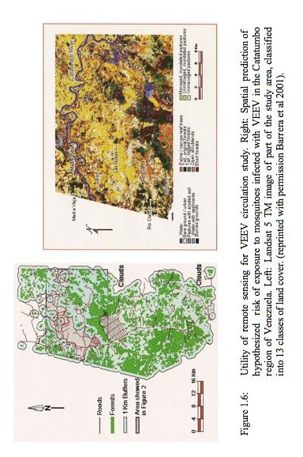
Field Location, “La Encrucijada” Reserve

The fieldwork described herein was performed in and around the “La Encrucijada” biosphere reserve in Chiapas state, Mexico. The preserve is located on the southwestern coast of Chiapas state (geographical coordinates 14° 14’—15° 40’ north; 92° 26’—93°20’ west) and encompasses an area of 357,824 acres (Figure 1.7). During the rainy season from May to November the annual rainfall is 1300—3000 mm with more rain occurring in the mountains (Instituto de Historia Natural, La Concepcion Meteorological Station). Temperatures fluctuate very little throughout the year with an annual average of 28°C.
There are 17 rivers and numerous streams that flow from the mountains and discharge into La Encrucijada wetlands creating and maintaining lagoons, marshes and swamps along the coast. The mangroves, considered the tallest on the American Pacific coast include yellow mangrove, white mangrove and red mangrove, the latter two of which are protected species. Besides mangroves the reserve also contains sub-perennial medium forest, low deciduous forest, floating and sub-aquatic vegetation, coastal dune vegetation and palm groves. There are 64 villages within the preserve and human agricultural activities consist of cattle farming, commercial fishing, subsistence agriculture and slash-and-burn agriculture. The area in between “La Encrucijada” and the Sierra Madre mountains, which run parallel to the coast about 25 kilometers inland, has been largely converted to orchards and cattle pasture.
In early October of 2005, several months before the fieldwork reported in this dissertation was begun, hurricane Stan made landfall on the Yucatan peninsula in southern Mexico. The storm occurred just after the peak of the rainy season and the combined effect resulted in an estimated 500 mm of rainfall within several days. This caused the many rivers in the area to flood up to 10 times their previous width (Nature Conservancy press release). Severe flooding and mudslides resulted that subsequently caused the destruction of bridges, roads, crops and homes throughout the area. According to local inhabitants the entire study area was under water for several days after the storm. The extent and effect of this flooding on local wildlife populations is unknown.
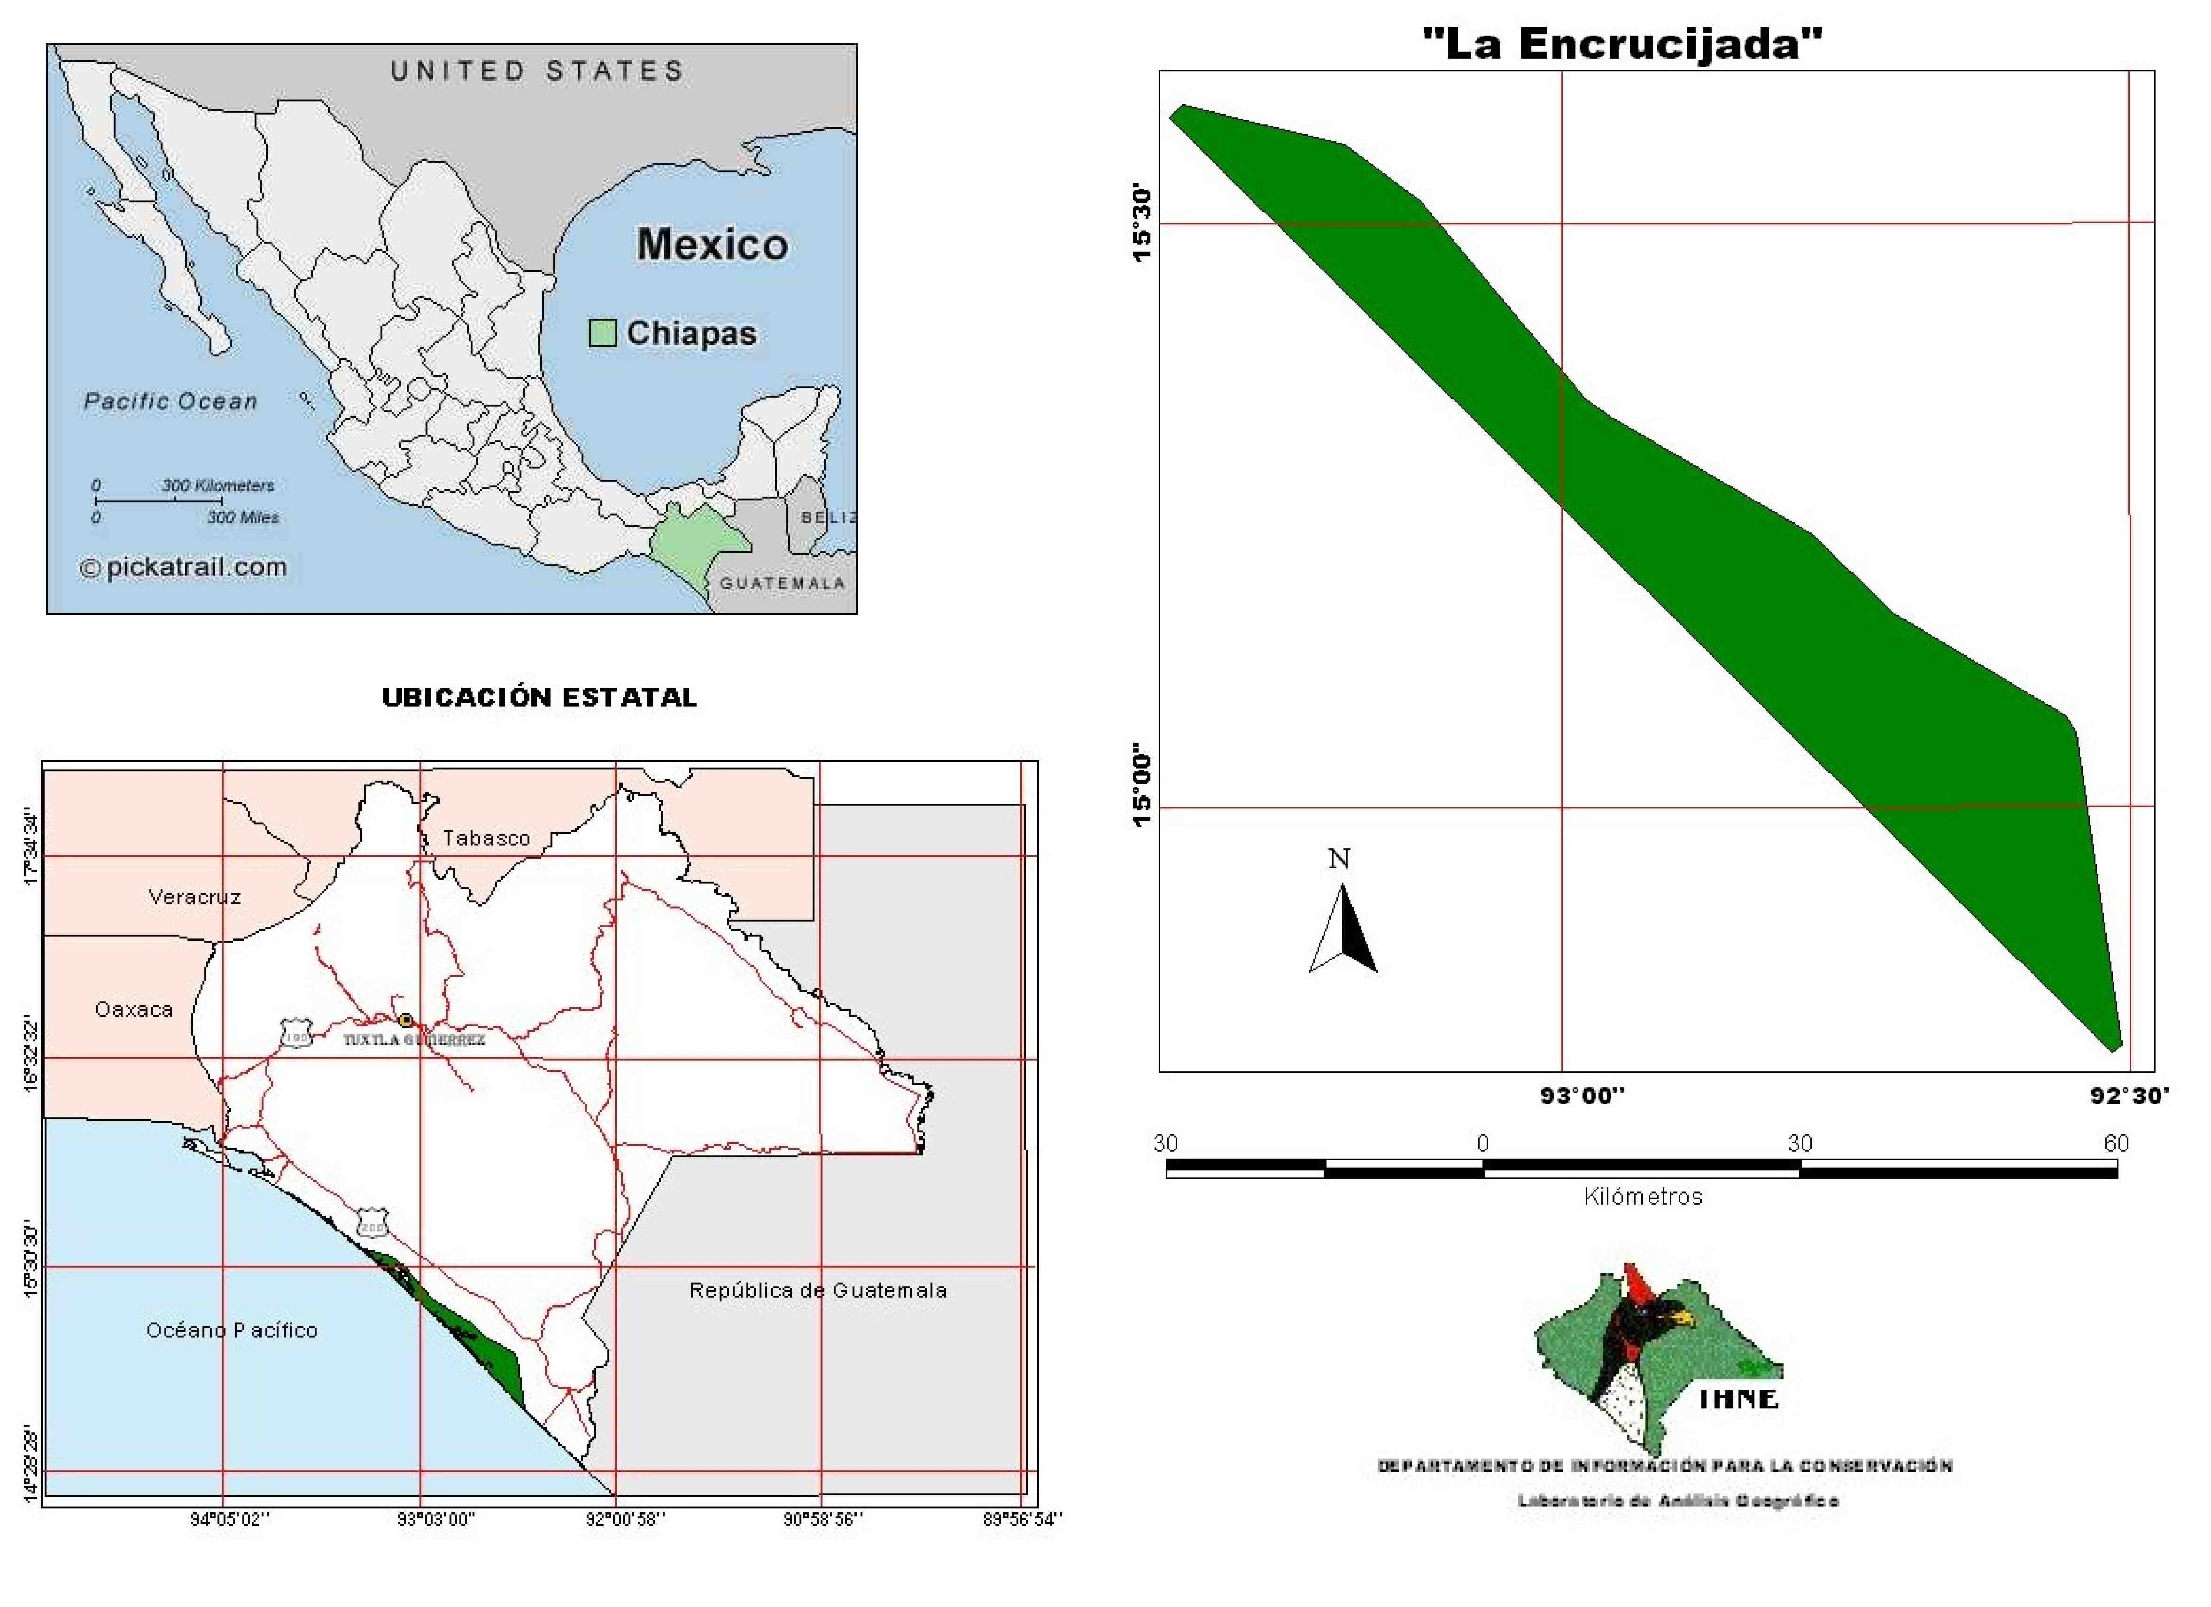
Figure 1.7: La Encrucijada biosphere reserve, the site of this study, is located on the Pacific coast of Chiapas, Mexico.

Significance

The ability to cause acute neurological disease, the lack of an acceptable human vaccine and its potential for use in bio-terrorism has earned VEEV a place on the CDC’s select agent list. Vector switching and habitat destruction contribute to VEEV re-emergence and must be clearly understood in order prevent and control disease outbreaks. The positive identification of the subtype IE VEEV vector species and reservoir species coupled with mapping of the habitat will greatly facilitate this understanding. In addition to the threat to human health, the central economic role of agriculture in these communities makes VEEV an especially important pathogen. The research described herein is geared towards understanding the mechanisms involved in viral adaptation and the emergence of equine-virulent viruses from avirulent precursors.
The emergence of equine-virulent subtype IE VEEV from avirulent subtype IE precursors does not strictly follow the paradigm for epizootic emergence. Subtype IE does not reliably cause viremia in horses, yet it can still cause fatal disease. These equine-virulent strains have demonstrated improved infection in epizootic vector mosquitoes but have never been evaluated in enzootic vectors. It is possible that equine-virulent subtype IE VEEV strains represent an intermediate phenotype that is neither classically enzootic nor classically epizootic. Or, perhaps these strains represent a more highly evolved phenotype that is able to infect both epizootic and enzootic mosquito vectors.

Specific Aims

Venezuelan equine encephalitis is a potentially fatal re-emerging disease in Mexico, Central and South America that can involve outbreaks involving hundreds-of-thousands of humans and equines. The 1993 outbreak in Chiapas Mexico, and the 1996 outbreak in Oaxaca, Mexico were unusual in that they were caused by subtype IE VEEV, which is generally considered to be avirulent in equines. It has been shown that subtype IE VEEV differs from epizootic subtypes IC and IAB with respect to their capacity to infect certain vector species (Brault, Powers et al. 2002). Aedes taeniorhynchus is the mosquito vector species most often associated with large epizootics of VEE in South America (Weaver, Ferro et al. 2004). Although this is one of the most common mosquitoes found in Chiapas and Oaxaca it has been shown to be inefficient at transmitting enzootic subtype IE VEEV (Turell, O'Guinn et al. 2003). It remains unclear what caused some subtype IE VEEV strains in Mexico to gain equine virulence and which vector species is/are responsible for transmitting the virus during these outbreaks. Understanding this change is imperative to understanding arboviral re-emergence and its effects.
The main objectives of this project were to elucidate the dynamics of VEEV interactions with mosquito vectors and vertebrate reservoirs in changing ecology. Once the vector, reservoir and areas of greatest exposure are elucidated, future equine and human disease might be minimized, relieving a substantial economic strain on these communities.

Specific aim 1: Ecological Examination of VEEV in coastal Chiapas.
Sub-aim 1a: Longitudinal serosurvey of wild rodents.
The goal of sub-aim 1a was to determine primary mammalian reservoirs for epizootic subtype IE VEEV in coastal Chiapas. I hypothesized that sigmodontine rodents would have highest incidence of subtype IE VEEV-specific antibodies. Sigmodon hispidus has been shown to be an important reservoir in multiple natural VEEV transmission cycles and experiments have shown animals from populations sympatric to VEEV are able to survive high titer VEEV infections. Preliminary capture data showed both high abundance and high seropositivity among wild S. hispidus in the study area.
Sub-aim 1b: Longitudinal census of wild mosquitoes.
The goal of sub-aim 1b was to incriminate the insect vector responsible for transmitting subtype IE VEEV in the Mexican state of Chiapas. There have been no VEEV isolates made from mosquitoes in this area during or since the 1993 outbreak. I hypothesized that subtype IE VEEV emerged to cause encephalitic disease in horses after successfully adapting to Ae. taeniorhynchus as an enzootic vector. The mosquito species most often associated with subtype IE VEEV transmission are Culex (Deinocerites) pseudes and Culex (Melanoconion) taeniopus. These species are not associated with transmission of epizootic VEEV subtypes, nor were they very common in the areas of the 1993 and 1996 outbreaks according to previous study. Aedes taeniorhynchus is more susceptible to infection and thus better able to transmit Mexican subtype IE VEEV strains than Guatemalan subtype IE VEEV strains. Thus Ae. taeniorhynchus was considered the most likely vector of equine-virulent subtype IE VEEV in Chiapas.
Sub-aim 1c: GIS correlation of circulation data with remote sensing
The goal of sub-aim 1c was to develop a multi-parameter predictive model for VEE outbreaks. We hypothesized that land use data compiled with VEE epidemiologic data would provide a reliable spatial predictive model. Remote sensing and satellite imagery combined with GIS can show how vector and reservoir habitats overlap with areas used in agriculture. This can be used to help determine conditions of highest risk for future VEE outbreaks.

Specific aim 2: Amplifying host assessment in the laboratory of wild-caught rodents for efficient amplification of sympatric VEEV.
The goal of specific aim 2 was to determine the suitability of the five most frequently captured rodent species from the study area to serve as amplifying hosts for equine-virulent subtype IE VEEV. I hypothesized that Sigmodon hispidus animals would develop higher and longer lasting viremia than animals from other species and would survive infection. Sigmodon hispidus animals have been shown to be efficient amplifying hosts of sympatric VEEV-complex viruses and preliminary capture data revealed higher incidence of VEEV-specific antibodies in S. hispidus animals compared to other commonly captured rodents.

Specific aim 3: Vector competence assessment in the laboratory for transmission of VEEV by mosquitoes from Chiapas.
The goal of specific aim 3 was to determine the infection efficiency of Culex (Mel.) taeniopus for equine-virulent strains of subtype IE VEEV. I hypothesized that these strains would infect a high proportion of mosquitoes and efficiently disseminate to the mosquitoes salivary glands. This mosquito has been shown to be better at transmitting enzootic VEEV subtypes than epizootic VEEV subtypes and it is considered the primary vector of enzootic subtype IE VEEV in Guatemala. Equine-virulent strains of subtype IE VEEV that were isolated during the outbreaks have been shown to infect the epizootic vector species Ae. taeniorhynchus more efficiently than older, equine avirulent strains. These strains of subtype IE VEEV have never been experimentally assessed in the enzootic vector Cx. taeniopus to determine whether this mosquito may maintain them in inter-epizootic circulation.

Description of “La Encrucijada” comes from the Information Sheet on Ramsar Wetlands prepared by Francisco Javier Jimenez Gonzalez, La Encrucijada Biosphere Reserve, 3ra. Oriente sur #1621, Barrio La Pimienta, Tuxtla Gutierrez, Chiapas.

